Kaosblade
Kb's Tutorial for A2 Permanent Patching

Please note: as of 31st August 2010 there is NO FREE method for red to brown conversion! so please don't ask and save boysie the pain!

Please use at the end of the post if you found this helpful.
I WILL NOT TAKE ANY RESPONSIBILITY IF YOU KILL OR DAMAGE YOUR PHONE. THIS IS ENTIRELY AT YOUR OWN RISK.
IF IT DOES HAPPEN, REFLASH YOUR PHONE'S MAIN/FS. HAPPY PATCHING.

Tools you will need

(all download links are available in the second post of this topic with installation help)
Omnius Server (account needed)
A2 Uploader (latest version or 19.09.2009+)
A starting patch you want to use
Sony Ericsson A2 Phone
CodeClaw CXC Patcher (v0.3+)
Far Manager
Den-Po's FAR CXC Patcher Plugin
Darkmen's FAR SEFP2 FileSystem Plugin

IF YOUR PHONE IS CERTIFICATE BROWN PLEASE SKIP TO STEP 9.
IF YOUR PHONE IS CERTIFICATE RED PLEASE START FROM STEP 1.
From step 9 you can choose between 3 different A2 permanent patching methods. All of them involve using A2uploader. Either A2 Uploader, CodeClaw CXC Patcher or den_po's Far CXC Patcherplugin. All of them work.
1. Start Up Omnius & enter your registered acount details by pressing the "settings" button and clicking "server settings".
2. Choose your phone on the top left. A full list of phones that can be browned for free: http://bit.ly/allaoN
3. Click Advanced & the following dialogue should show.
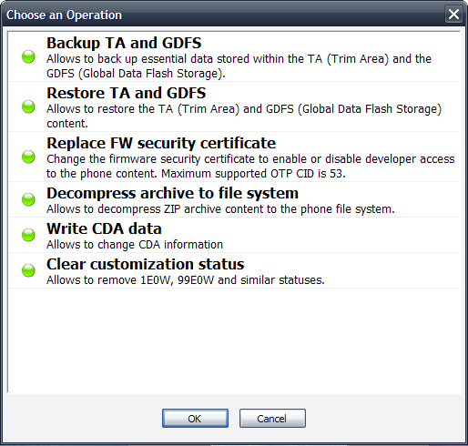
4. Click "Replace FW Security Certificate" and click OK.
5. Now choose "Brown Certificate (developer)" under the drop down and click OK. We need brown to patch.
6. Remove the phone battery and wait at least 5 seconds before re-inserting it.
7. Connect the phone holding down the buttons 2+5.
8. Wait until the entire process finishes. Now your phone is brown and ready to patch.
To reverse:
Certificate Conversion
Follow exactly the same steps but on step 5 choose "Red Certificate (retail)". But why would you wanna do that.
A2 Uploader Method - Easiest yet slowest.
9. Open up A2 Uploader.
10. Where it says "MISC" browse for the VKP patch you want.
11. Now where it says "E" click it and the patch should open up in notepad.
12. Add this line to the beginning of the patch.
;pAtChFiLe=/boot/phone_app.cxc
Make sure there are no gaps or spaces in this. This normally gives an "ACK" fs error.
13. Hit CTRL + S. Or save it. (This can be done before step 15.)
14. Now on A2 Uploader click "WRITE SCRIPT".
15. Connect your phone as usual, but this time hold down "c". If your phone's power button is "c" then connect with 2+5.
16. Wait. A2 Uploader takes a long time. Even with small patches. When a popup comes up click "NO". Wait some more.
17. After it says, "ELAPSED: xx secs." it has ended, and you can unplug your phone.
That's it! You have successfully patched your A2 CID 52 phone!
Now to keep patching you only need to start from step 14.
To reverse:
Patching
At step 15 click "YES" using exactly the same settings.
CodeClaw CXC Patcher Method - Not hard to understand, and faster than A2 Uploader.
9. Open up A2 Uploader or FAR SEFP2 (see "advantages between different methods" below).
10. Click "FileSystem Tool".
11. Connect your phone as usual, but this time hold down "c". If your phone's power button is "c" then connect with 2+5.
12. Wait. On the right you should see your phone's FS.
13. Double Click "/BOOT".
14. Now, right-click "phone_app.cxc" and click "Read". A2 Uploader will download your phone_app.cxc to a folder called "ph_out" which is located somewhere in the A2 Uploader program dir.
15. Click "SHUTDOWN FS MANAGER".
16. You do not need to repeat the last steps after completed once. As phone_app.cxc is saved on your computer.
17. Now time for some CodeClaw magic! Open up CXC Patcher.
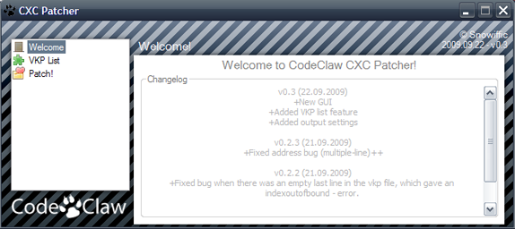
18. On the left click "VKP LIST".
19. Click the "Add" button and browse to your patch.
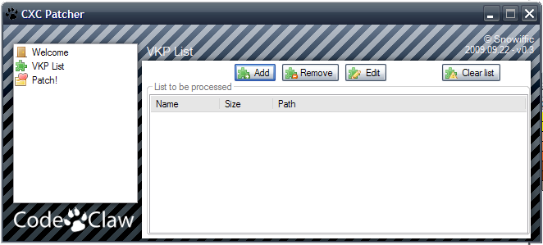
20. The best thing about CXC Patcher is that multiple patching is available! To do this...
By clicking the "Add" button you can keep adding patches. They appear in the "VKP List". The program has a nifty feature of adding and removing them. You can also Edit them but this is not needed.
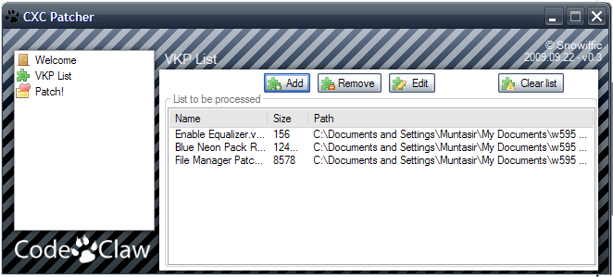
21. After you have decided what patches to apply in the "VKP List". On the left click, "Patch!".
22. In the input box, browse for the "phone_app.cxc" you downloaded using A2 Uploader.
23. In the output box, browse to the place you want the patched "phone_app.cxc" to end up. (After patching).
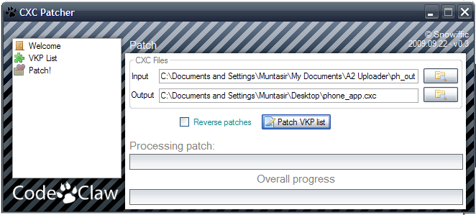
24. To start patching, click "Patch VKP List". CXC Patcher is faster than A2 Uploader because we have already downloaded the "phone_app.cxc" manually. Whereas in the A2 Uploader method it is done automatically by adding a line into the patch.
This is not needed for CXC Patcher.
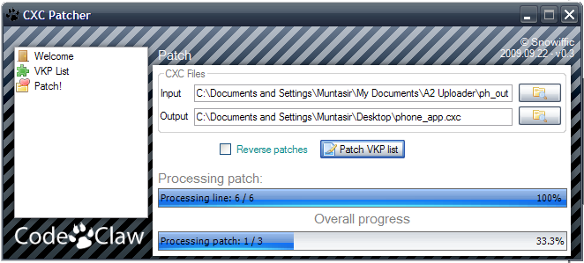
25. After the bottom bar has reached 100% the patching is done.
26. Now reupload the phone_app.cxc that was outputted back to your phone's FS in "/BOOT".
27. This is obviously done using A2 Uploader or FAR SEFP2 (see "advantages between different methods" below)..
To reverse:
One or more patches without removing all
Add the patches you want to remove into "VKP List".
And in the "Patch!" section tick the box "Reverse Patches".
All Patches
Re-upload your original "phone_app.cxc" using A2 Uploader.
Den_Po's FAR CXC Plugin Method - Hardest but fastest and best.
9. Open up A2 Uploader or FAR SEFP2 (see "advantages between different methods" below).
10. Click "FileSystem Tool".
11. Connect your phone as usual, but this time hold down "c". If your phone's power button is "c" then connect with 2+5.
12. Wait. On the right you should see your phone's FS.
13. Double Click "/BOOT".
14. Now, right-click "phone_app.cxc" and click "Read". A2 Uploader will download your phone_app.cxc to a folder called "ph_out" which is located somewhere in the A2 Uploader program dir.
15. Click "SHUTDOWN FS MANAGER".
16. You do not need to repeat the last steps after completed once. As phone_app.cxc is saved on your computer.
17. Now for some of that legendary software by Den_Po! Open up FAR Manager.
18. On the left side browse to where your downloaded "phone_app.cxc" is located.
19. On the right side browse to where your patch(es) is/are located.
20. Now, on the left open "phone_app.cxc" by double clicking it.
21. Just for the purposes of understanding, on the left you now have an open "phone_app.cxc" ready to be patched. (Just like the list feature in the CodeClaw method).
22. On the right click on the patch you want to use. And hit F5 on your keyboard. Then it will ask for confirmation and just click "copy" that comes up in the grey box.
23. The patch is written to your .cxc ready to be patched. (Again just like the list feature in the CodeClaw method).
24. You can also add more patches again before patching. (Multiple patching).
25. Now to apply the patches. On the left above all the patches you have copied, there should be a "..." (which refer's to the parent folder).
26. Double click on this.
27. A dialog box should pop up and should say "saving" with a loading bar. This is when the patches are all applied.
28. Wait until this is done and you should be taken back to where you opened "phone_app.cxc" from.
29. Your "phone_app.cxc" is now patched, and ready for re-uploading!
30. Now reupload the phone_app.cxc that was outputted back to your phone's FS in "/BOOT".
31. This is obviously done using A2 Uploader or FAR SEFP2 (see "advantages between different methods" below)..
To reverse:
One or more patches without removing all
Open the "phone_app.cxc" like in step 21 and delete any of the patches in the list and click "..." to save.
All Patches
Re-upload your original "phone_app.cxc" using A2 Uploader.
-----------------------------------------------
Advantages between different methods - which one is the best?
A2 Uploader => Automatically download's and uploads everything for you. Although this makes the patching process very slow and doesn't usually allow multiple patching. + adding the extra line to the patch can be a nightmare.
CodeClaw CXC Patcher => Very fast patching. Multiple patching makes life a whole lot easier (if you're brave enough ). Although, you have to download & upload everything manually using A2 Uploader or Far SEFP2. However, you don't have to add any extra lines to the patch(es)
Den_po's FAR CXC Patch Plugin => The fastest method of A2 patching known. Period. Supports multiple patching and there is no patching line needed to be added to patches. As this is a FAR plugin, it is convienient to use FAR SEFP2 to upload back the phone_app.cxc without having to touch other programs.
Corman, on 20 August 2010 - 05:42 PM, said:
The quickest way to upload is to have SEFP2 open in the right pane and FAR CXC patcher in the left pane. Then you can just close phone_app.cxc and drag it to the right.
The best method known as of 20/08/2010 is....
FAR MANAGER! This way you only need to open one program*, it's fast, it's multiple patching and it's simple! A2 patching couldn't be made easier by Den_Po & Darkmen. All you need is CXC & SEFP2 plugins installed. It's genius. ;D
*(unless you need to brown, then you use Omnius once) (:
Quote
ChangeLog
22/09/2009: Tutorial Posted
05/10/2009: Codeclaw CXC Patcher Method (after BETA stage)
07/10/2009: Den_po's FAR CXC Patcher Plugin Method
14/11/2009: Known Errors/Issues & How to fix them.
26/11/2009: ALL Screenshots & Formatting.
15/08/2010: Aerix method replaced with Omnius!
20/08/2010: FAR SEFP2 plugin information added.
Hope it helps. Any questions feel free to ask. There's lots of experts to help.

SECOND POST: INSTALLS
Installation Guide
Den_Po's FAR CXC Patcher Plugin Installation Instructions
Okay this is really simple.
1. Download Far Manager 2.0 Stable from the page in the 3rd link above.
2. Download the attachment in the first post in the page of the 4th link above.
3. Now extract everything you downloaded as the Far Manager which is in .7z format using WinRAR to a nice little place that you can easily access on your computer.
4. Now extract the file called "farcxcplugin.dll" IN THE 2.0 FOLDER to the folder called "Plugins" which is in the Far Manager folder you just extracted in step 3.
5. Now making sure that "farcxc plugin.dll" is located in "/FAR/Plugins". You can now start using FAR.Omnius Server
A n00b could do this. I don't even know why I'm explaining this.
In the first link download and double-click the installation .exe file. This will install Omnius Server ready for use.

Credits:
Jinx13 for discovering the cert conversion method! Good on ya'!
the_laser for A2 Uploader..
Everyone that took part in the development of Aerix and D-Ultimate Unlocker!
CodeClaw for CXC Patcher. <3
Den_po for the check sum calculator & Far Plugin.
MASVA for FAR and D-Ultimate screenshots
The mind-boggling guys who develop Omnius.
That's it. I think that everyone can easily use everything else. Hope this all helps.

